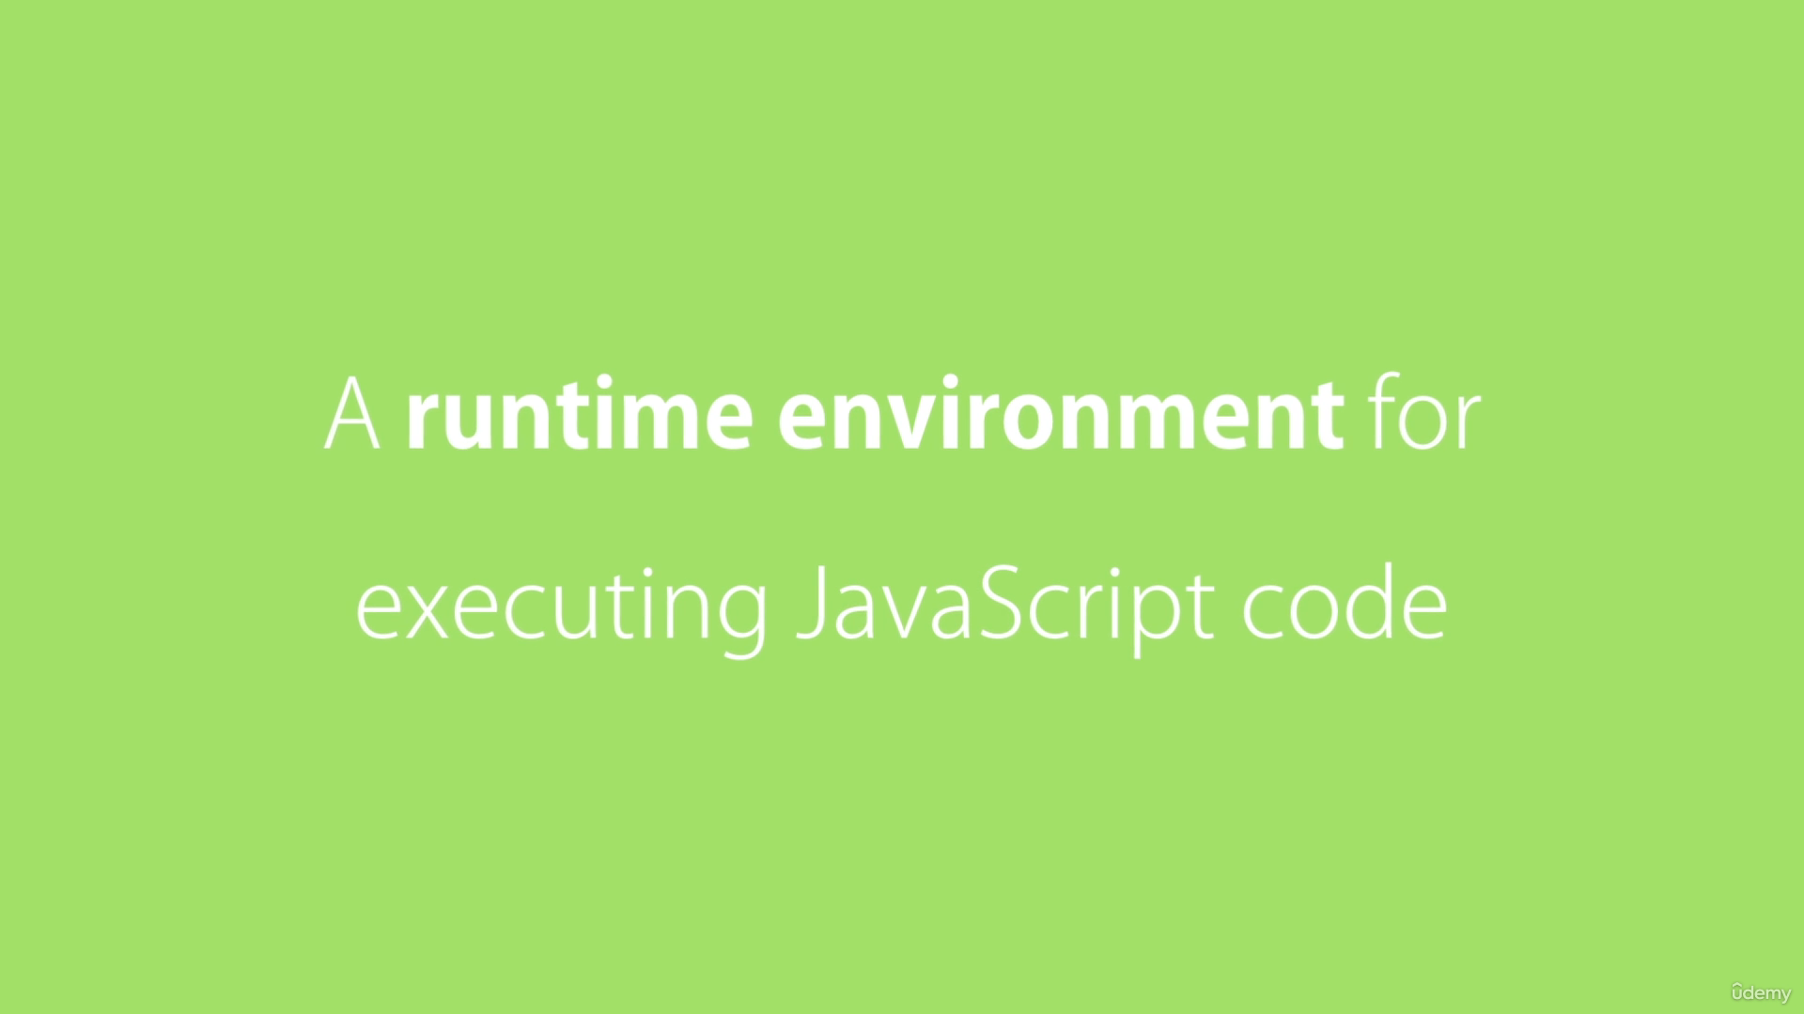

Node is open source and cross platform runtime environment for executing JavaScript code outside the browser.

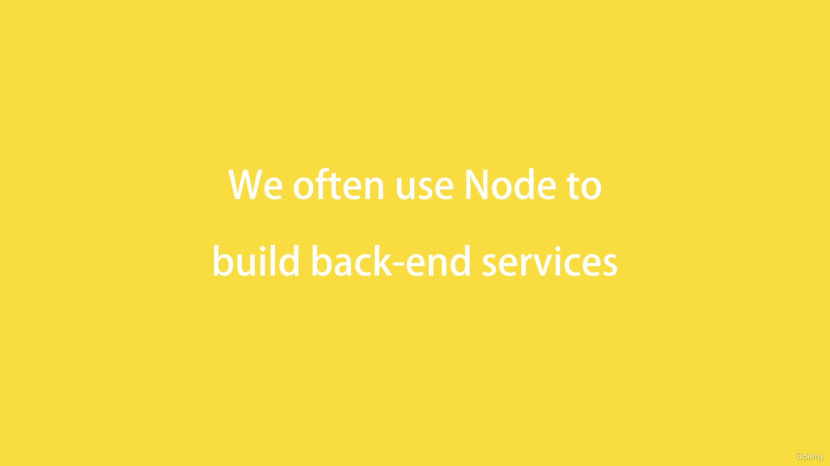



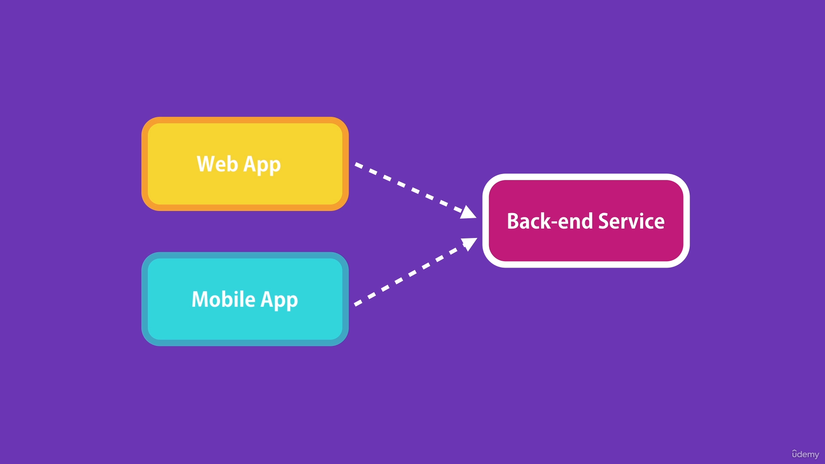

Quite often we use node to build backend services like APIs. These are the services that power the client applications like web apps running in the browsers and mobile apps running in the mobile devices. These client apps need to talk with some services on the server or on the cloud to store data, send emails, push notifications etc.

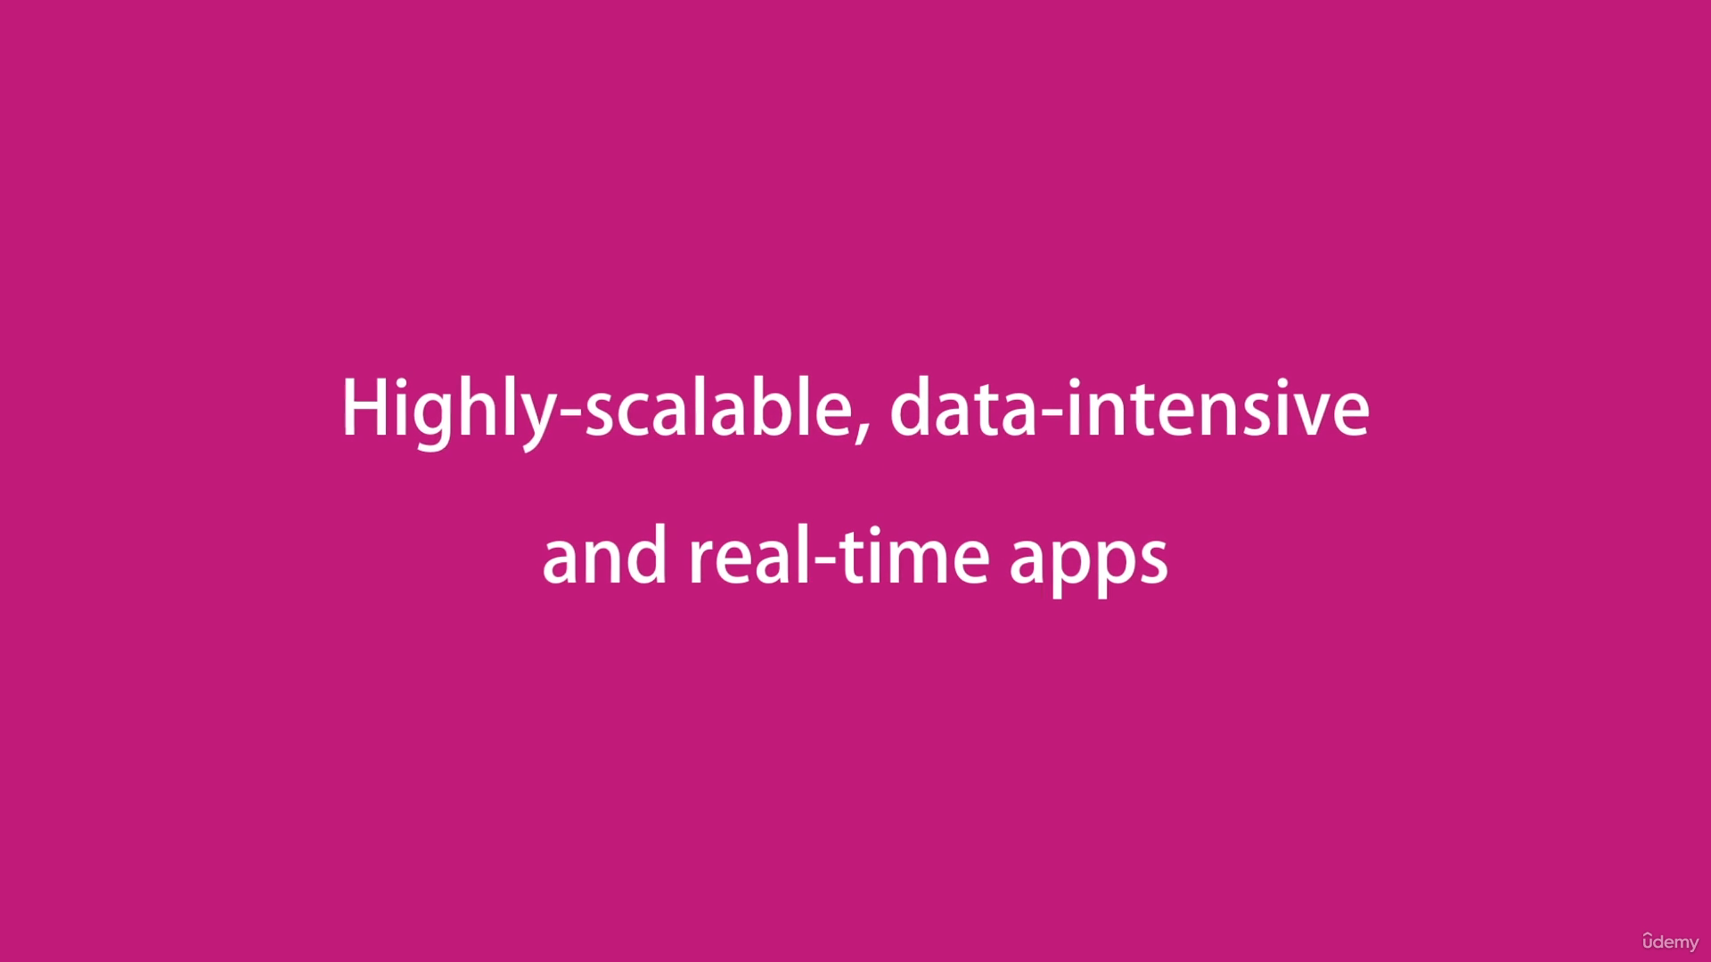

Node is ideal for building highly scalable, data intensive and real time backend services.

